Associate Editor's Comments:  
Both reviewers requested dexamethasone measurements and reference to human pharmacology. Ideally these studies might be performed on leftover serum from animals used in these studies. If none is available, measurements on comparably treated animals is acceptable or historical data but only if measured in your laboratory. I note that steroid hormone measurements, including synthetic dexamethasone, must conform to journal policies.  
  
**Reviewer Comments:  
Reviewer 1: This is a solid study reporting on the combination of obesity and chronically elevated glucocorticoids leading to exacerbations in metabolic function. I feel this work is potentially worthy of publication with the inclusion of the following data:**  
In order to confidently draw comparisons between the DEX-treated chow-fed versus high-fat fed groups, it is important to demonstrate that the method of DEX administration (via the drinking water) results in comparable elevations in serum DEX. There is a possibility that the exacerbated metabolic function observed in the high-fat fed mice was simply due to increased consumption of the DEX-treated drinking water in these animals. As such, a measurement of serum DEX, in both the DEX-treated chow-fed and DEX-treated high-fat fed groups should be included.

Response: We have measured the concentrations of dexamethasone these mice were consuming (via measurement of drinking water throughout the study; A-C below) as well as the serum concentrations (via LCMS; D). The obese dexamethasone-treated mice did consume more dexamethasone when compared to lean and this was reflected in serum concentration. While this is a limitation of our study, we do not believe that this fully accounts for the more aggressive phenotype observed in these mice. Insert correlation data. Additionally, it is important to note that the obese dexamethasone-treated mice were severely diabetic with marked fasting hyperglycemia, which is likely the cause of this accelerated water intake noted in the third week of treatment, as has been documented previously by others (1). Unfortunately, we were expecting that these mice would respond so dramatically and therefore did not account for this in our study design.

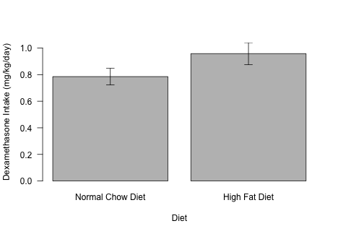

B

A

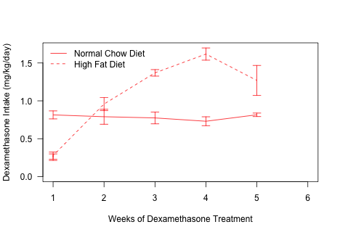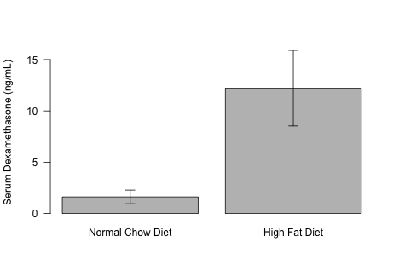

C

D

Minor points

1. The figures 1A, 1B, 1C and 1D appear to be mislabeled in the legend.

Fixed in both the legends document and main document-if you want to see what I changed please refer to fig legend document.

1. There are typographical errors on both lines 278 & 406.  
   Fixed 278, removed sentence with typo in 406 as it regarded patients (acknowledgements).   
     
   **Reviewer 2: Authors assessed some metabolic effects of increased glucocorticoid in combination with obesity induced by hyper-caloric feeding (in mice). Authors speculate that this combination of events is present in "many individuals". Therefore they propose that pre-clinical studies on this topic are needed. The results are very descriptive, in line with expectation, and no mechanism of action has been identified. Thus, this study is very descriptive and its results expected.**  
     
   Main criticisms:  
   1) If authors wanted to mimic the clinical glucocorticoid treatment in mice, then was the increase in circulating glucocorticoid content experimentally-induced in mice comparable to the level seen in humans undergoing glucocorticoid therapy?

Response: We measured intake of dexamethasone weekly throughout the study and found that mice were receiving less than 1mg/kg/d. Though this is at the high end, it is within the clinical range administered to humans, which is generally from 0.75-9mg/d and up to 3mg/kg/d (~210mg for an average American male), depending on the patient’s condition (2,3). Please see below for references.

1. **Lee SM, Bressler R.** Prevention of diabetic nephropathy by diet control in the db/db mouse. *Diabetes* 1981;30(2):106–111.

2. **Tyrrell JB, Findling JW, Aron DC, Fitzgerald PA, Forsham PH.** An overnight high-dose dexamethasone suppression test for rapid differential diagnosis of Cushing’s syndrome. *Ann.Intern.Med.* 1986;104:180–186.

3. **Fleseriu M, Biller BMK, Findling JW, Molitch ME, Schteingart DE, Gross C, Auchus R, Bailey T, Biller BMK, Carroll T, Colleran K, Fein H, Findling JW, Fleseriu M, Hamrahian A, Katznelson L, Kerr J, Kipnes M, Kirschner L, Koch C, Lerman S, Lyons T, McPhaul M, Molitch ME, Schteingart DE, Vaughan TB, Weiss R.** Mifepristone, a Glucocorticoid Receptor Antagonist, Produces Clinical and Metabolic Benefits in Patients with Cushing’s Syndrome. *J. Clin. Endocrinol. Metab.* 2012;97(6):2039–2049.

Please also see: https://reference.medscape.com/drug/decadron-dexamethasone-intensol-dexamethasone-342741

2) What is the novelty of this study?

Response:

3) Fig. 1A: In relative terms, insulin-induced changes in glycemia are similar between the 4 groups. Please, show data as percentage change over basal.

Response: Dexamethasone leads lower glucose clearance in both lean and obese mice; however, in the lean mice this difference is not significant between the treatment groups. It is important to note that the insulin dose was high (2.5 U/kg; generally, for chow mice we give 0.75-1.0 U/kg) since obesity is known to cause insulin resistance and these animals may not respond to lower doses which may prevent the observance of changes between the obese treatment groups. Since we wanted to compare all 4 groups we administered the same dose. However, at a lower dose of insulin we do see significantly lower glucose clearance in the dexamethasone-treated, chow-fed mice when compared to controls. (I will find the low-dose figure to add here)

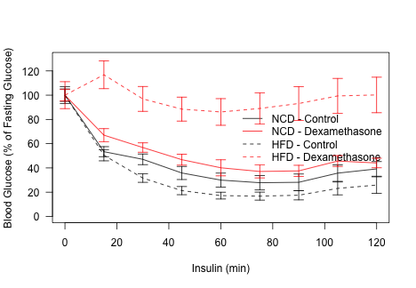

4) Fig. 1C-F: What is the effect of glucocorticoid treatment on these parameters in NCD mice? Are these effects exacerbated in HFD?

Response: It is difficult to interpret data from the chow-fed (lean) animals in the clamp as the controls and dexamethasone treated animals had differences insulin clearance rates. Therefore, even though the groups were given the same dose, the dexamethasone-treated group cleared insulin more slowly than controls resulting in increased circulating levels throughout the clamp. With that said, dexamethasone-treated mice had higher circulating insulin yet similar glucose responses as controls and these data are consistent with what we observe with the ITT. Unfortunately, we cannot compare the lean mice to the obese mice for these particular data due to the discrepancy in circulating insulin.